**CBDC Worldwide 2021**

# C:\Users\hjibbawi\Desktop\chart.png

# Introduction

Central banks admit the critical role of CBDC in the digital transformation era nowadays. CBDC should be secure, safeguard privacy, and offer cash-like convenience. Nevertheless, different technical approaches are behind achieving these criteria.

The first technical issue is whether CBDC should be decentralized or centralized. Clearly, a fully-open, permissionless design is not feasible, due its lack of central control, with key concerns including compliance provisions and the lack of due diligence.

The second issue is whether access should be account-based or token-based. Ownership is tied to an identity, and transactions are authorized via identification, as in bank accounts. On the other hand, efficiency and speed are the advantages of a token-based approach with disadvantages summed up by scalability and flexibility concerns with bank’s lack of experience in DLT. Central banks are exploring hybrid systems.

The third issue is whether the architecture is one-layered or two-layered in which user would have the ability to hold digital currency in either their digital wallets or deposit them into a traditional bank account.

Accordingly, countries differ in their technical and design approach of their own CBDC. The below report summarizes the most popular CBDC projects.

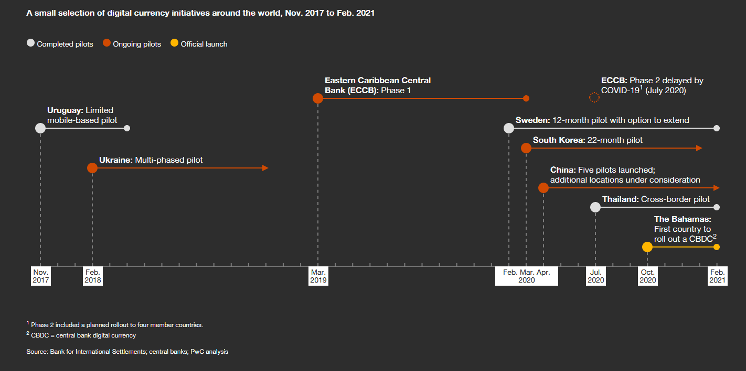

# Bahamas

The Bahamas Central Bank implemented its own CBDC called “Sand Dollar”. Sand Dollar is pegged to the Bahamas Dollar, which is, in turn, pegged to the U.S. dollar. So, it can be considered as a pilot release of U.S. dollar by proxy. Sand dollar is domestic, so it cannot be held non-domestically. It can be used for the domestic wholesale and retail transaction.

The digital currency ecosystem supports digital payments, and composed of Authorized Financial Institutions (AFI) that include money transmitter businesses, payment service providers, and commercial banks. AFI provides services to the customers such as KYC/AML checks, wallet services, and custodial services for the sand dollar.

Bahamas digital wallets are designed to function in three tiers: the lowest tier limits the amount of sand dollar and does not require KYC/AML requirements. While the two other tiers have a risk based approach to KYC. However, higher amounts are taken into custody of the appropriate AFI. A multi-factor authentication secures the wallet. But the protection against SIM-swapping is still unknown.

Also, a digital id solution was created in parallel with the sand dollar.

Technically, NZIA was the Bahamas’ solution provider. Its novel consists of NZIA CortexDLT – a blockchain – at its foundation, hardware nodes running the platform, and a hybrid wireless network at the top that allows the mobile devices connection. Loss of power is a crucial feature in Bahamas. In this case, the wallet is synchronized eventually when the connection returns again.

# China

China is a robust CBDC front-runner; it aims to become the first major central bank that releases CBDC. Digital Yuan is designed to replace cash in circulation not to replace long-term deposited money in bank accounts. In future, People’s Bank of China (PBOC) is working to internationalize the yuan and restrict the dollar-dominated global banking system.

PBOC conducted five internal trials of their digital currency electronic payment (DC/EP) in three big cities, including tests on paying goods and food delivery. Currently, PBOC is rolling it out on major e-commerce platforms within the country. Yet, the estimated launch timeline remains unrevealed.

In Brief, digital yuan is hyper-centralized, controlled by PBOC and integrated into the existing banking system. China will adopt two-tier architecture, with the PBOC managing the backend infrastructure, overseeing the digital ledger, and issuing digital cash to the big state-owned banks and leading payment companies. In the second tier, payment providers and financial institutions will distribute digital yuan to individuals and businesses via digital wallets.

China’s CBDC features are summarized as follow:

* DC/EP is built on centralized ledger technology instead of blockchain and DLT.
* Delivers “Controllable Anonymity” through anonymous front-end (user level) and real name back-end (PBOC level) structure.
* Reflects compliance requirements (KYC, AML, CFT, etc.)

Even though digital yuan has a domestic focus, PBOC has recently joined a cross-border digital currency payment project in collaboration with Thailand, Hong Kong, and United Arab Emirates.

# Sweden

Sweden’s Riskbank has recently launched the third testing phase of E-Krona (Sweden’s CBDC). This project is assessed by a case study that simulates the daily bank activities such as payments, deposits, and withdrawals from digital wallets. Riskbank is consulted by Accenture and uses R3’s Corda platform.

Riskbank claimed that CBDC DLT tokens cannot provide cash-like features more than an account-based. The major cash features are: lack of traceability and the ability to operate when offline. Token-based digital currency will fail to work offline correctly; its vulnerable to double spending issue through the reconciliation operation once the device returns online. On the other hand, account-based digital currency implies certain level of traceability; the ledger is held by a third-party organization. For that, Riskbank sees that the two features are not applied in both account-based and token-based.

Regarding the offline functionality, Riskbank mentioned that there exist real offline solutions allowed on payment cards. For instance, central bank can limit the number of times a token can be moved before it is reconciled to the ledger. Visa also reported a solution that requires the payer to use a device with secure enclave, and an intermediary or wallet provider to allocate funds to a mobile phone for offline use.

Sweden’s Riskbank proposed a value-based closed system with two-tier architecture and a global notary (consensus) node. The first tier consists of three different node types: Riskbank node that issues kronor (the token) to Participant (banks) node and a Notary node that confirms transactions. The second tier describes the distribution of kronor to end-users.

The case study shed light on the role and relevance of technology providers and consultants. Certain technology providers, R3 in particular, appear to be dominating the provision of distributed ledger technology frameworks for CBDCs. Sweden’s e-krona seems to be the “generic R3 package”. The role of consultancies such as Accenture can be understood as “translating” between the functional expectations and the technical implementation.

When assessing the e-krona within this framework, it becomes evident that various design specifications have not yet been made. As such, the current e-krona prototype is exciting, potentially even representative of the most common development status, but most likely neither pioneering, nor the most advanced CBDC set-up.

# Republic of Marshall Islands

Marshall Islands launches its central bank digital currency – Marshallese sovereign (SOV) – on Algorand blockchain protocol, while SFB Technologies is the company that develops SOV’s blockchain infrastructure. Algorand is an open-source blockchain protocol provider, permissionless and with proof-of-stake protocol. It also allows the development of scalable blockchain solutions for real use cases. So, the Algorand protocol will be implemented to provide the SOV initiative with speed, scalability, and security. The protocol also provides the required compliance controls such as identity management and the compliance platform.

“Marshall Island’s vision is for global participation and inclusion in an open financial system by harnessing the benefits of blockchain technology. It is consistent with a truly global and decentralized society. We also believe it made possible with our technology. We are proud to support the country on its revolutionary journey towards the adoption of digital currency, “said Silvio Micali, founder of Algorand.

The island nation aims to reduce its dependence on the US dollar, which is currently the national currency. Algorand clarified that the SOV would circulate alongside the US dollar. The SOV supply will algorithmically fix at 4% growth per year to prevent inflation.